**Ye, Zhengkun**

**EECS 2500**

**Project 1**

[**Ye.zhengkun@rockets.utoledo.edu**](mailto:Ye.zhengkun@rockets.utoledo.edu)

**08/31/14**

**A:**

package com.arrays;

import java.io.BufferedReader;

import java.io.IOException;

import java.io.InputStreamReader;

import java.util.ArrayList;

import java.util.Scanner;

import java.util.Vector;

public class Arrays {

public static void main(String[] args) throws IOException{

System.out.print("Enter the size:");

Scanner sc = new Scanner(System.in);

int size = sc.nextInt();

int[] arr = new int[size];

System.out.print("Enter " + size + " integers (end by -1):");

int num, cnt = 0;

while(sc.hasNext())

{

num = sc.nextInt();

if(num == -1)

break;

arr[cnt++] = num;

}

for(int i = 0; i < size/2; i++)

{

int tmp = arr[i];

arr[i] = arr[size - i - 1];

arr[size - i - 1] = tmp;

}

System.out.print("Output:");

for(int i = 0; i < size; i++)

{

System.out.print(" " + arr[i]);

}

}}

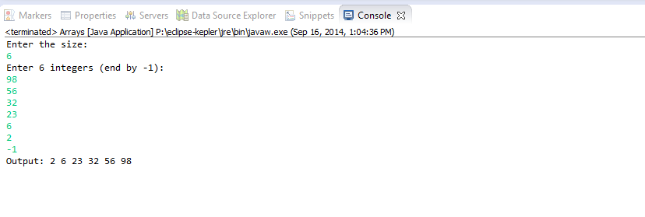

**B:**

**package** com.die;

**public** **class** Die {

**private** **int** value;

Die(**int** val)

{

value = val;

}

**public** **void** draw()

{

**switch**(**this**.value)

{

**case** 1:

System.*out*.println("*");

**break**;

**case** 2:

System.*out*.println("*");

System.*out*.println("*");

**break**;

**case** 3:

System.*out*.println(" *");

System.*out*.println("* *");

**break**;

**case** 4:

System.*out*.println("* *");

System.*out*.println("* *");

**break**;

**case** 5:

System.*out*.println("* *");

System.*out*.println(" *");

System.*out*.println("* *");

**break**;

**case** 6:

System.*out*.println("* *");

System.*out*.println("* *");

System.*out*.println("* *");

**break**;

}

}

}

**package** com.die;

**public** **class** CreatePairOfDice {

**void** pairDraw()

{

**int** number1 = (**int**)(Math.*random*()*10) % 6 + 1;

Die die1 = **new** Die(number1);

System.*out*.println("Die 1");

die1.draw();

**int** number2 = (**int**)(Math.*random*()*10) % 6 + 1;

Die die2 = **new** Die(number2);

System.*out*.println("\nDie 2");

die2.draw();

}

**public** **static** **void** main(String[] args)

{

CreatePairOfDice cpd = **new** CreatePairOfDice();

cpd.pairDraw();

}

}

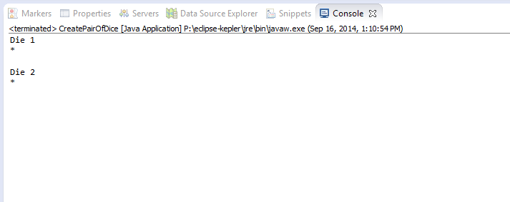

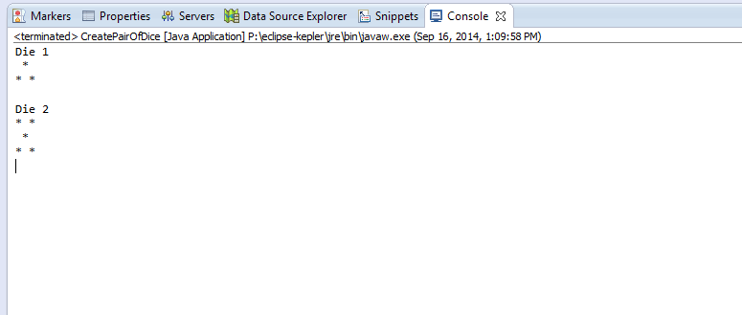

**C:**

**import** java.awt.BorderLayout;

**import** java.awt.Dimension;

**import** java.awt.Panel;

**import** javax.swing.JFrame;

**import** javax.swing.JButton;

**import** javax.swing.JPanel;

/**

*

* **@author** Administrator

*

*/

**public** **class** GUIInterfaces {

**public** **static** **void** main(String[] args) {

JFrame f=**new** JFrame("BorderLayout");

//f.locate(200,200);

JButton btn = **new** JButton("Linear Data Structures.");

JPanel panel = **new** JPanel();

panel.setPreferredSize(**new** Dimension(400, 40));

panel.setBackground(java.awt.Color.*blue*);

panel.add(btn,BorderLayout.*CENTER*);

f.add(panel,BorderLayout.*SOUTH*);

JPanel panelw = **new** JPanel();

panelw.setPreferredSize(**new** Dimension(200, 80));

panelw.setBackground(java.awt.Color.*PINK*);

btn=**new** JButton("Java");

panelw.add(btn,BorderLayout.*WEST*);

btn=**new** JButton("Programming");

panelw.add(btn,BorderLayout.*EAST*);

f.add(panelw,BorderLayout.*WEST*);

JPanel panele = **new** JPanel();

panele.setPreferredSize(**new** Dimension(200, 80));

panele.setBackground(java.awt.Color.*YELLOW*);

btn=**new** JButton("IS NOT SO EASY");

panele.add(btn,BorderLayout.*EAST*);

f.add(panele,BorderLayout.*EAST*);

f.pack();

f.setVisible(**true**);

f.setDefaultCloseOperation(JFrame.*EXIT_ON_CLOSE*);

f.setLocationRelativeTo(**null**);

}

}

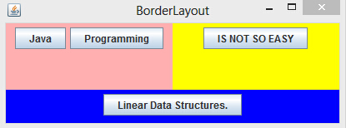

**D:**

**import** java.io.File;

**import** java.io.FileNotFoundException;

**import** java.io.PrintWriter;

**import** java.util.Scanner;

**import** java.util.Random ;

**public** **class** Sort {

**public** **class** number

{

**int** num;

**public** number ()

{

num=0;

}

**public** number (**int** newNum)

{

num= newNum;

}

**public** String toString ()

{

**return** num+"\n";

}

}

**public** number [] arrayNum ;

**public** **int** capacity;

**public** **int** size;

**public** Sort (String filename)

{

size = 0;

capacity=50;

arrayNum = **new** number[capacity];

Scanner infile = **null**;

**try**

{

infile = **new** Scanner (**new** File (filename));

}

**catch** (FileNotFoundException x)

{

System.*exit* (0);

}

**while** (infile.hasNext ( ))

{

**int** i = infile.nextInt();

arrayNum [size++] = **new** number (i);

}

infile.close ( );

}

**public** **static** **void** main(String[] args)

{

Sort a = **new** Sort ("1-50.txt");

System.*out*.println (a);

Sort b = **new** Sort ("50-1.txt");

System.*out*.print(b+"\n");

Sort c = **new** Sort ("random.txt");

System.*out*.print(c.arrayNum[0].num);

**int** []newArray = **new** **int** [50];

**for** (**int** i=0; i<50; i++)

{

newArray[i] = c.arrayNum[i].num;

}

*InsertionSort*(newArray);

**for** (**int** i=49; i>=0; i--)

{

System.*out*.print("\n"+newArray[i]);

}

}

**public** String toString ( )

{

String outstring = "";

**for** (**int** i = 0; i <50 ; i++)

{

outstring += arrayNum[i];

}

**return** outstring;

}

**public** **static** **void** InsertionSort(**int** [ ] list)

{

**int** j;

**int** key;

**int** i;

**for** (j = 1; j < list.length; j++)

{

key = list[j];

**for**(i = j - 1; (i >= 0) && (list[i] < key); i--)

{

list[i+1] = list[i];

}

list[i+1] = key;

}

}

}

